**DS LAB FILE**

**Name – Vaibhav Chawla**

**Roll no – 24/SCA/BCA(AI&ML)/070**

**Section – II-D**

**CODES**

1. **BINARY SEARCH**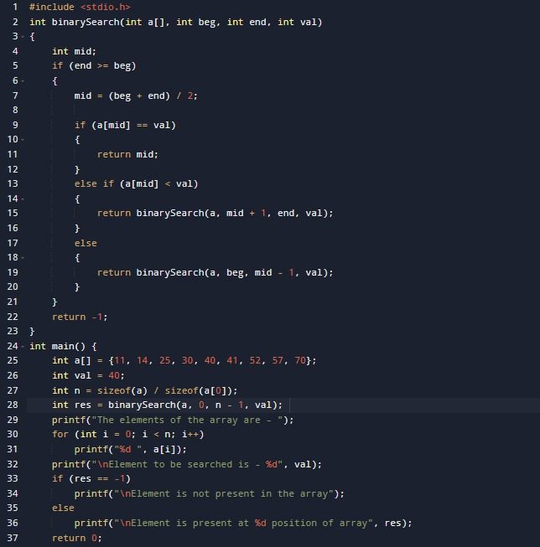

**OUTPUT**

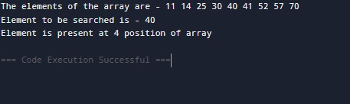

**2.PASSING ARRAY TO FUNCTION**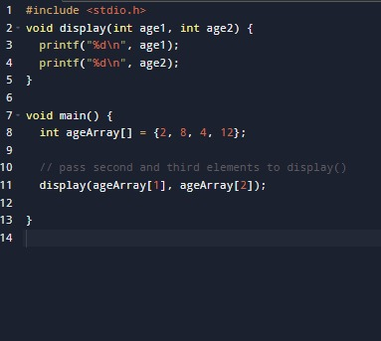

**OUTPUT**

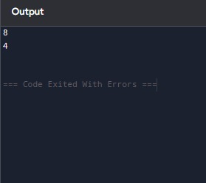

**3.LINEAR SEARCH**

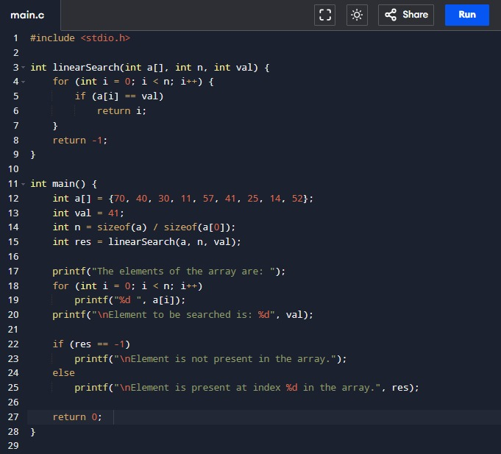

**OUTPUT**

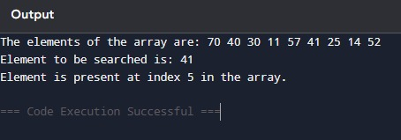

**4.Sparse Matrix**

**OUTPUT:**

**5.Stack Operations**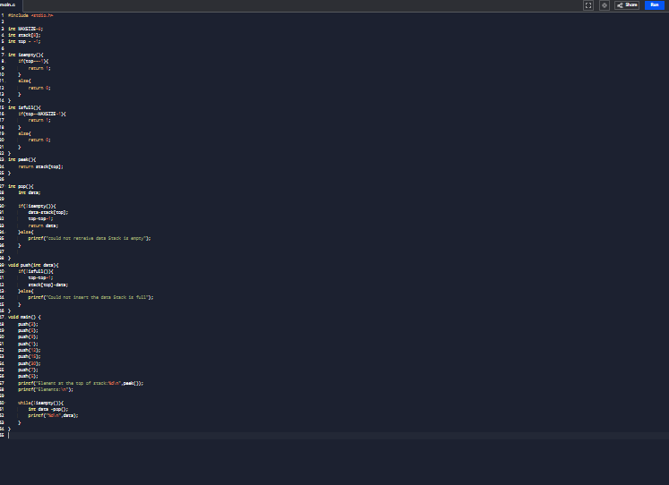

**OUTPUT**

